Database Application Development

Project – Assignment 2

Objective:
In this project students learn:
- How to create an Entity Relationship diagram for a database application
- How to implement an ERD of a database application in Oracle SQL server
- How to write and execute simple SQL queries and advanced SQL queries.

Submission Due: Saturday Aug 9th midnight

Project 2 – SQL implementation

• In this Project Assignment 2, you should do the tasks listed in the topic below. You must create and use the database ER diagram that is assigned to your group as given below.

Project Groups title
- Hospital management system
- Via Rail booking system
- Airline booking system
- Students course scheduling and grades viewing system
- House and Condo electricity bill viewing and payment system
- Library Management System
- TTC bus transit system
- Car rental system

Read the questions document carefully to know the tasks of each milestone.
Project Tasks:
- Entity-Relationship Diagram (ERD): Use draw.io
  - Design an ERD for your assigned store.
  - Include at least six relevant entities for the assigned store, with each entity having a minimum of five attributes. Exceptions can be made for bridge tables, which may have fewer attributes due to their specific role in modeling many-to-many relationships.
  - For each column, specify:
    - Data type (e.g., INT, VARCHAR, DATE)
    - Constraints (e.g., primary key, foreign key, unique, not null)
    - Default values, if any
- Database Creation:
  - Create tables based on the ERD using CREATE TABLE statements.
  - Ensure the inclusion of:
    - Primary keys
    - Foreign keys
    - Appropriate data types
    - Defined constraints as outlined in the data dictionary
- Data Insertion:
  - Insert at least 20 rows of meaningful data into each table using INSERT INTO statements.
- Advanced Queries:
  - Focus on implementing advanced queries that utilize:
    - If a team member has two tables, they must provide six different SQL queries.
    - Various types of joints (e.g., INNER JOIN, LEFT JOIN, RIGHT JOIN, FULL OUTER JOIN)
    - Views to simplify complex queries
    - The report should include diverse SQL operations such as GROUP BY, SUM, HAVING, UNION, INTERSECT, etc.
    - Avoid repeating the same SQL functions across all tables.
    - If a group has six tables, the report must contain at least 18 SQL reports with corresponding screenshots.

Part 1:

- Use draw.io
- Consult as a group to create an ERD (Entity-Relationship Diagram ) for the assigned application. Your ERD should include at least six tables. Ensure you define primary keys, required fields, unique constraints, check constraints, and default constraints. As database designers, your group must evaluate the cardinalities of the relationships between entities.

- Divide the entities among group members evenly for implementation.

- List the names of the group members next to the tables they will implement.

- Include this information in the report document.
Part 2:
- Each team member should implement their assigned tables from the ERD. Create the tables with the specified constraints. After creating the tables, include screenshots of the columns tab and constraints tab in the report.

- Add a minimum of 20 rows of meaningful data related to the given application. After adding the data, include screenshots of the data tab in the report.

- Share your data scripts with your team members, especially if they are implementing child tables.
Part 3:
- Each team member should implement six advanced queries based on the tables they have created, utilizing diverse SQL operations such as INNER JOINS, LEFT OUTER JOINS, GROUP BY, SUM, MIN, MAX, AVG, COUNT,HAVING, UNION, INTERSECT, MINUS
- Screenshots of SQL query execution results
- Clearly listed group member contributions (each member’s assigned tables and queries)

Part 4:
- Each group will record a video demonstration to present their ERD. In this video, each team member should:
  - Demonstrate the tables they have created and the data they have inserted.
  - Execute and explain one group by query, and one JOIN query based on their created tables.
Group Submissions: 2 files
Submission Requirements: Project Explanation Report with code, and Demo Video
Submission Platform:
All submissions must be made via Blackboard. You can submit all the 2 files requested below or you can share a OneDrive link or Google Drive link where all the project files are stored. Ensure the "Date Modified" for all files matches the project deadline.
Do not submit a zip file or .rar. Submit each individual file asked with group number naming convention.

Group20_ERD_Script_Queries.docx (Weight: 60 Marks)

  - All the Word documents should have the group number, topic given for the group and clearly mention the name of group members
  - ERD diagram for the group project
      - ERD clearly mentioning group members implementing the tables
      - PK, FK, required fields and relationships clearly done
  - Add the creation script
      - Clearly mentioning group members’ name who wrote the code for creation of the tables
  - Add the data script
      - Clearly mentioning group members’ name who wrote the code for creating and inserting values for the tables
  - Add the SQL report
    - Give the report title for each query -Group member who did it.
      - Example Showing all flights starting from ‘London’ and ‘British Airways’ airline- Done by John Doe. SQL select query for the report tile followed by SQL output screenshot.
    - Each team member should implement 4 SELECT queries based on the tables they have implemented with different WHERE clauses involving date or string or integer datatypes
    - Each team member should implement 2 JOIN queries
    - Each team member should implement 2 VIEW queries

Group20_demoVideo (Weight: 40 Marks)

      - Record a group demo video (maximum duration: 6-9 minutes). Each member should take approximately 2-3 minutes to:
      - Introduce themselves, their group number, and their teammates.
      - Explain the ERD of the project they worked on.
      - Share the Oracle SQL Developer to show the tables and data created by the team member. Show execution of one SELECT query with WHERE clause and one JOIN query
      - The video must be professionally presented, with the following requirements:
        - No phone recordings.
        - Include a video of the presenter.
        - Ensure clear audio narration by the presenter.
        - Use screen sharing to showcase the code and its output.
        - A penalty will be applied if these requirements are not met.
***************************************************************************************

Appendix A
All documentation files should have group number, group project title, group members name and their contribution mentioned next to their work in tables and SQL queries

EXAMPLE OF submission

Project 2

Due: Submission of Project 2 files in Blackboard by Saturday Aug 9th midnight.

DO NOT submit a ZIP file and naming convention should be followed as given in deliverables.

Example Submission:

Group Number :20
Topic: Library Management System
Team Members
- John Doe implemented tables A and B
- Jane Smith implemented tables C and D
- Joe Wilson implemented tables E and F

ERD for the application name

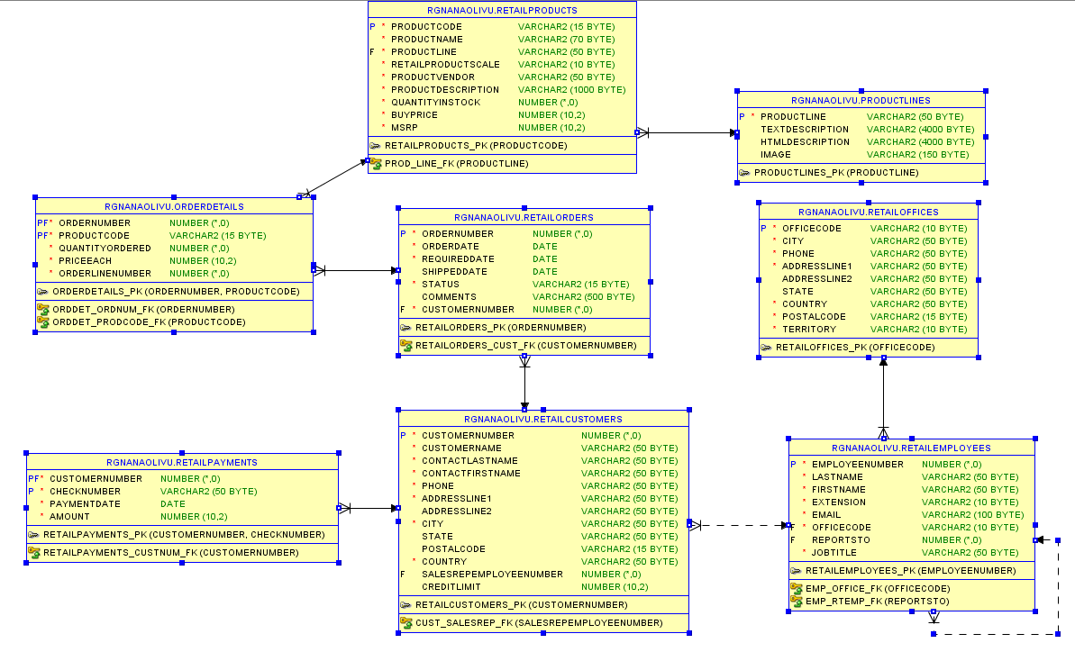

SQL Creation Script

-- John Doe implemented table books--
CREATE TABLE BOOKS (
bookId NUMBER(5) PRIMARY KEY,
bookName VARCHAR(50) NOT NULL,
author VARCHAR(50) NOT NULL,
genre VARCHAR(30) NOT NULL,
costPrice NUMBER(4,2) NOT NULL,
sellingPrice NUMBER(4,2) NOT NULL,
CONSTRAINT genre_chk FOREIGN KEY (genre) REFERENCES GENRES(genre)
);
SQL Insertion Script
-- John Doe implemented table books--
INSERT ALL
INTO BOOKS VALUES (2001, 'Pario Ki Kahaniaan', 'Husn Pari', 'Fairy-tale', 15.09 , 24.81)
INTO BOOKS VALUES (2002, 'How to Break a phone', 'Funny Kanishka', 'Novel', 6.63, 33.72)
INTO BOOKS VALUES (2003, 'How to set annoying alarms', 'Roomie Navleen', 'Thriller', 24.54, 33.90)
INTO BOOKS VALUES (2004, 'How to snore', 'Roomie Jiya', 'History', 24.72, 42.09)
INTO BOOKS VALUES (2005, 'Hours ni milre yaar', 'Shiv', 'Comedy', 15.54, 24.18)
INTO BOOKS VALUES (2006, 'OOP and me', 'Harshil', 'Romance', 60.90, 51.90)
INTO BOOKS VALUES (2007, 'I want to swim', 'Sun Cheet', 'Biography', 51.63, 60.45)
SELECT * FROM DUAL;
SQL Queries

Example of an Advanced SQL Report:
  - Query 1: Completed by John Smith
  - Description: Retrieves sales representative numbers who have customers with the highest credit limits.
  - 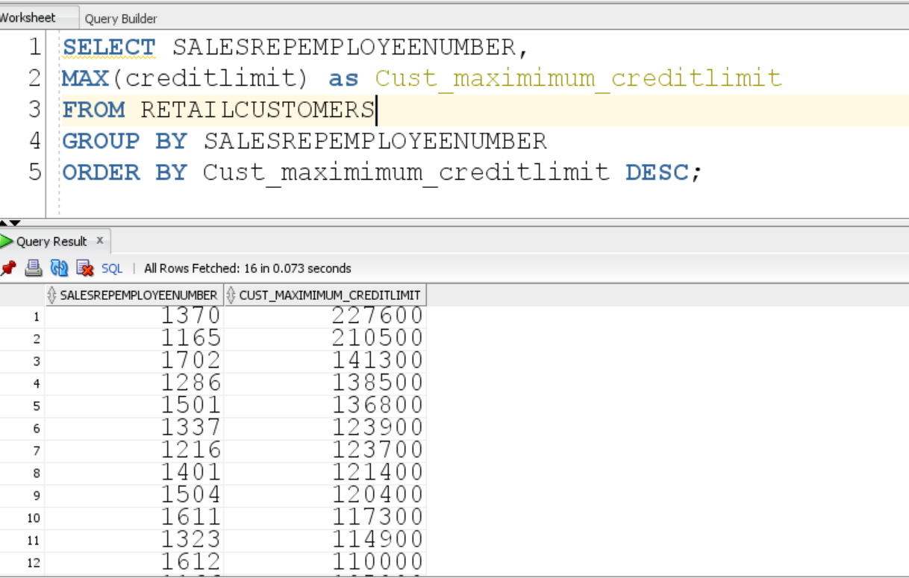

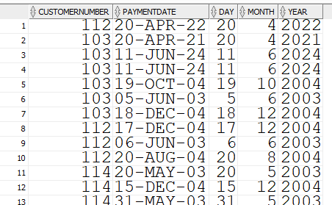
***************************************************************************************

DROP TABLE DEPARTMENTS CASCADE CONSTRAINTS;
DROP TABLE DOCTORS CASCADE CONSTRAINTS;
DROP TABLE PATIENTS CASCADE CONSTRAINTS;
DROP TABLE APPOINTMENTS CASCADE CONSTRAINTS;
DROP TABLE MEDICAL_RECORDS CASCADE CONSTRAINTS;
DROP TABLE MEDICATIONS CASCADE CONSTRAINTS;
DROP TABLE PRESCRIPTIONS CASCADE CONSTRAINTS;

select * from departments;
select * from doctors;
select * from patients;
select * from appointments;
select * from medical_records;
select * from medications;
select * from prescriptions;

